Aditya Sharma Programming Language used: Python

**Solving ODE using RK-4 method**

Scenario A Velocity vs time plot (time step= 0.2)

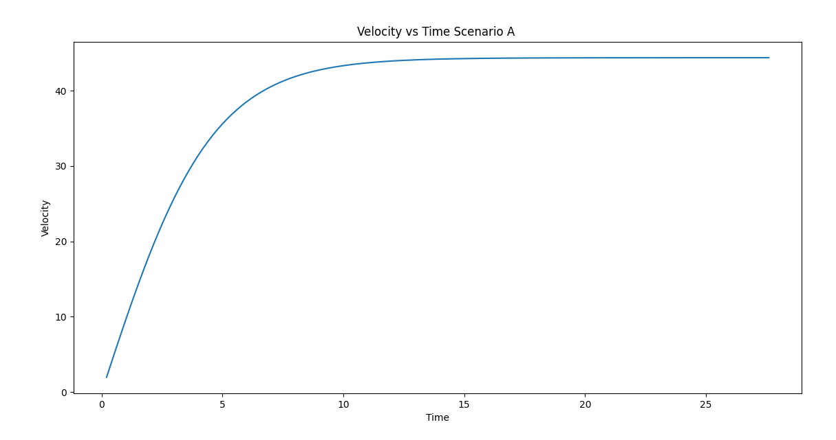

Error |v_analytical –v_numerical| at each time step Scenario A

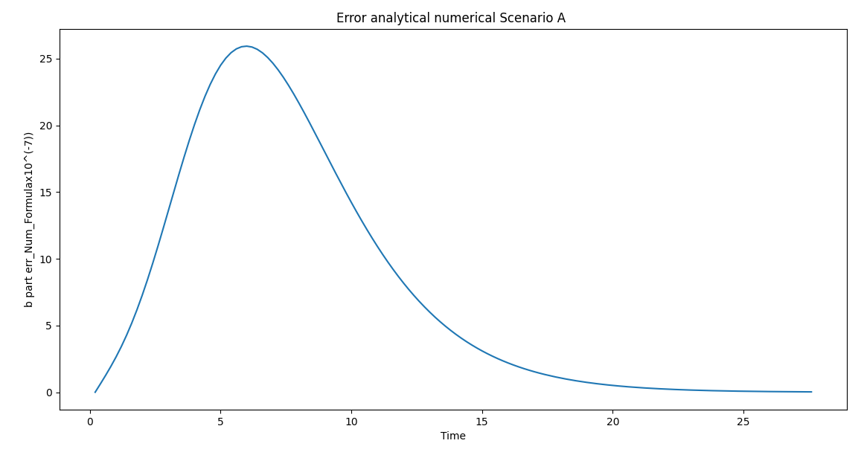

Velocity vs time Scenario B (time step= 0.2)

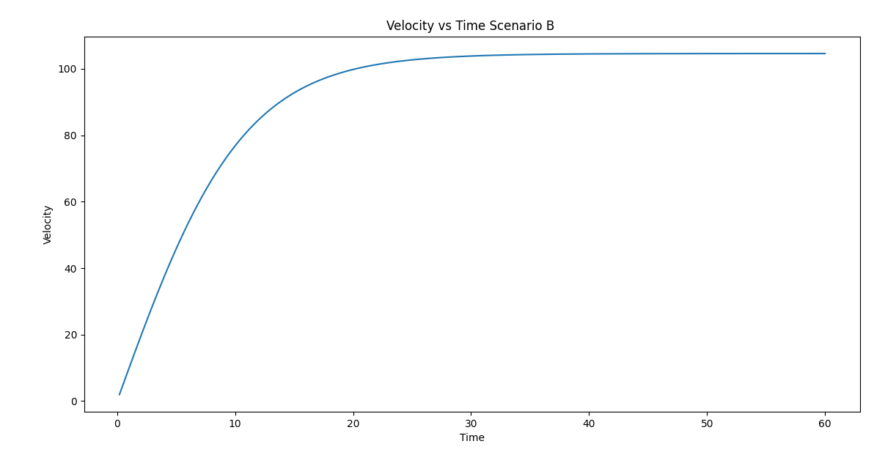

Error |v_analytical –v_numerical| at each time step Scenario B

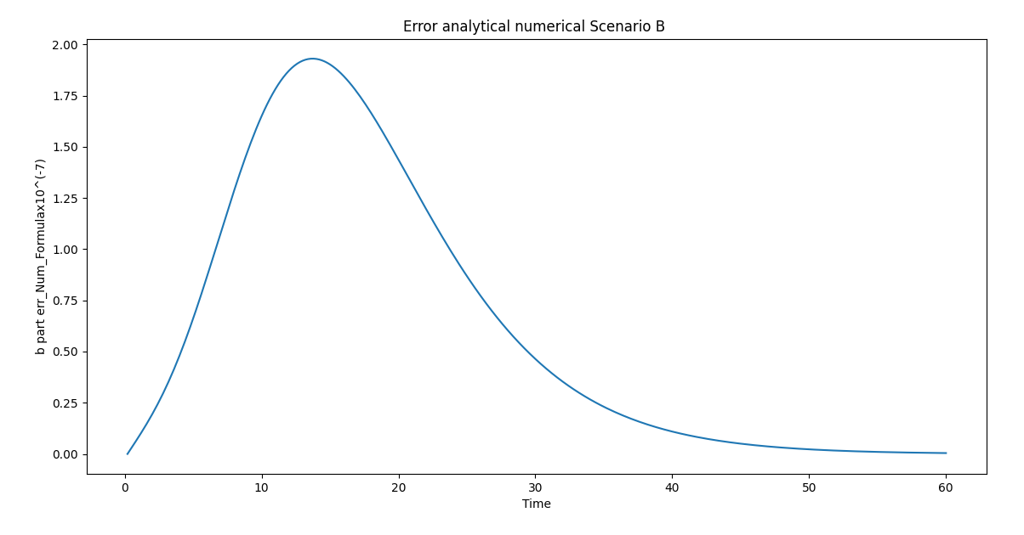

RMS Errors with changing (Step Size h) – Scenario A

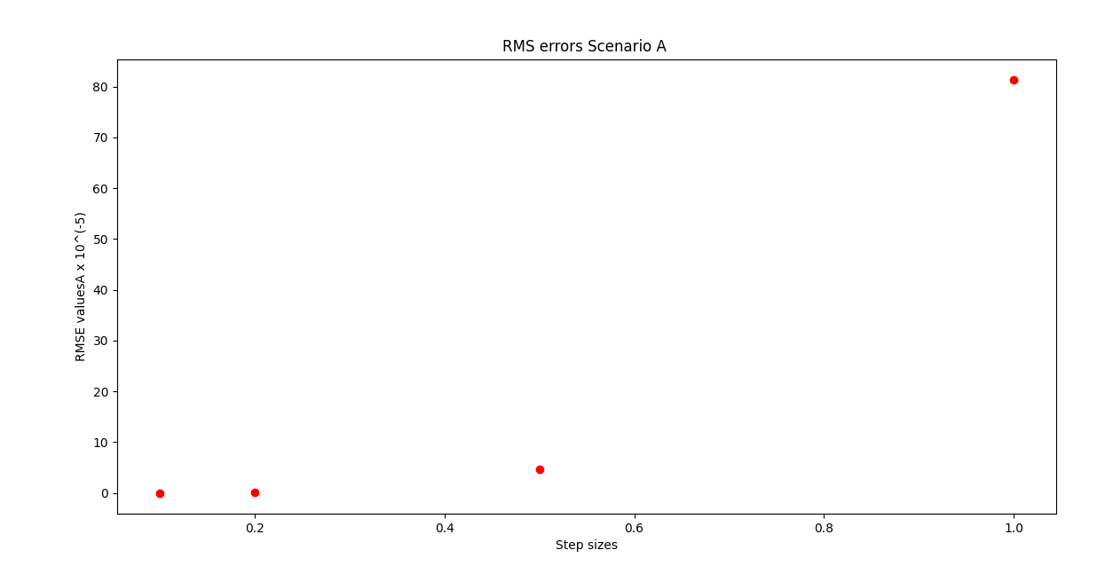

RMS Errors with changing (Step Size h) – Scenario B

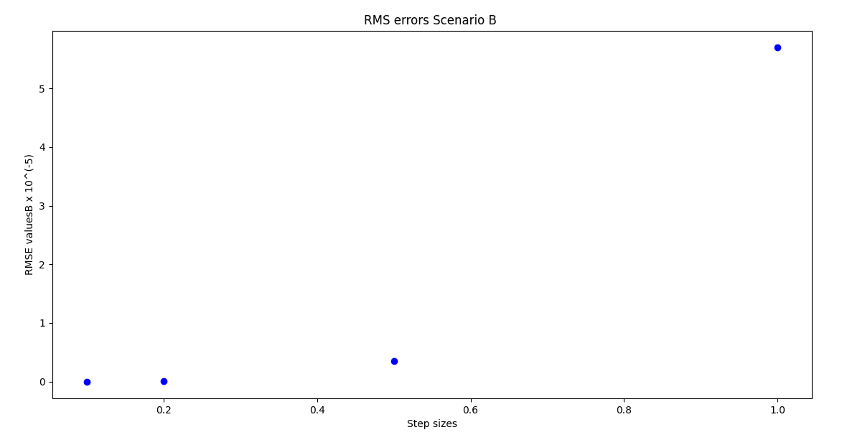

Output Python terminal answers Scenario A

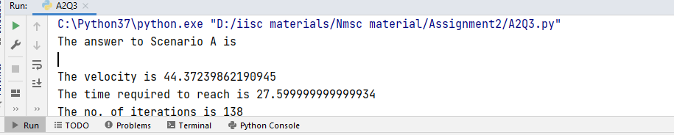

Output Python terminal answers Scenario B

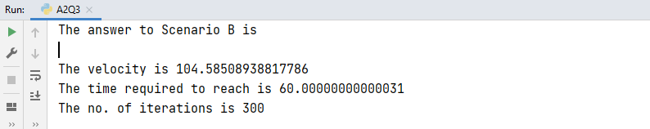

Q3 Sub Problem II Using Gaussian 3 point Quadrature

Distance error plots Scenario A

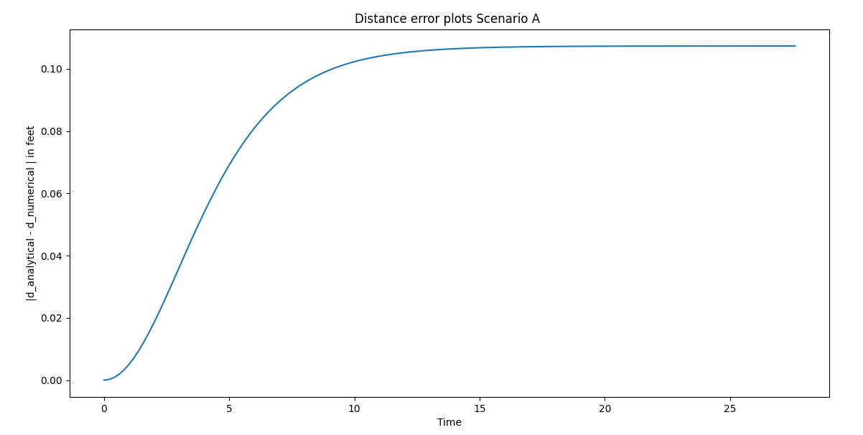

Distance error plots Scenario B

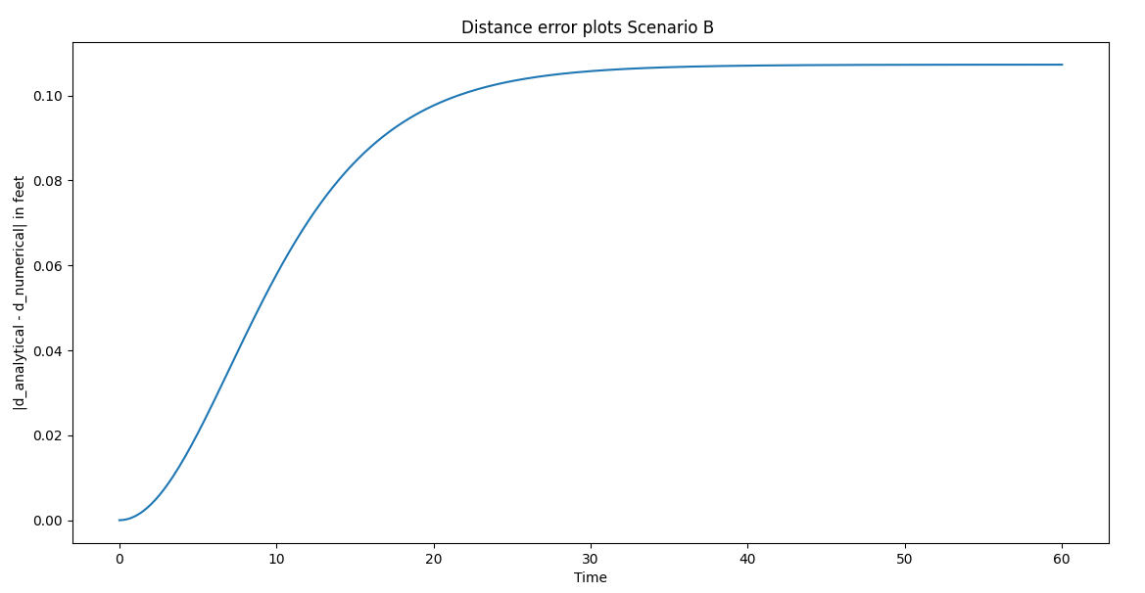

Output Python Terminal Scenario A

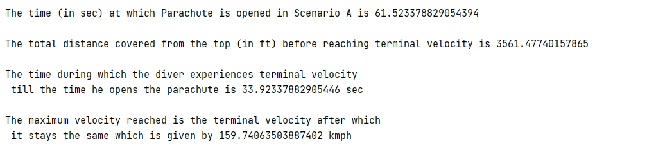

Scenario B has 2 cases:

One if we ignore the 13,500 ft jump assumption then we get the INITIAL answer

But if we take the 13500 ft altitude jump by diver, then we get the TRUE case as shown below.

Output Python Terminal Scenario B INITIAL OUTPUT

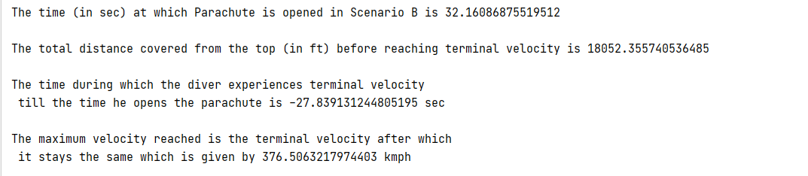

True output Scenario B

